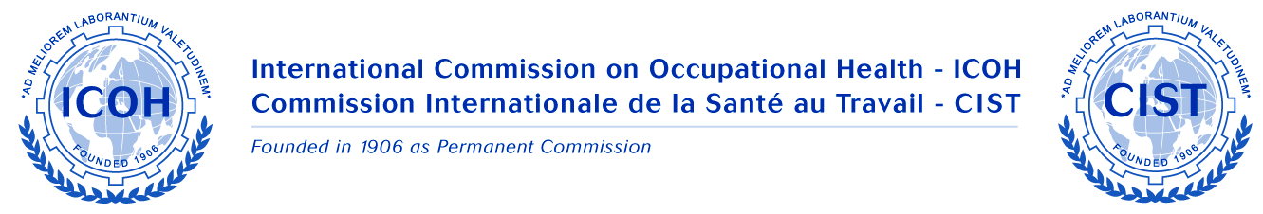

ICOH Newsletter N° 2 August 2010, on Page 10 and 11, there is a report of various meetings of ICOH we organized in Argentina, during our XVI ARGENTINEAN CONGRESS ON OCCUPATIONAL HEALTH, in Neuquén, Patagonia - Argentina

On Friday 21st May, during this Congress, the Meeting of National Secretaries of Latin America, was held and attended by:

Dr. Raul Barañano (NS Uruguay
Dr. José Carneiro (NS Brazil)
Dr. Ruddy Facci (past Vice President and Honorary Member), Brazil
Eng. Rodrigo Munita Necochea Chile who attended on behalf of Dr. Veronica Herrera (NS)
Dr. Jorge Morales Mexico (Board Member) on behalf of Dr. Elia Enriquez (NS)
Dr. Cristina Pantano (NS Argentina)
Dr. Antonio Werner Argentina (Honorary Member)
Dr. Claudio Taboadela Argentina (Board Member)

The Meeting was chaired by Dr. Claudio Taboadela (Board Member) who at the beginning of the meeting read the letter sent by VP wishing every success to the Congress and the NS meeting. Dr. Morales made a presentation on the ICOH Monterrey Congress in 2012, inviting all Latin American OH physicians to attend.

Dr. Taboadela spoke about the need for developing research on OH in the region and the aim that Latin American OH physicians could access the position of secretary or chair of Scientific Committees.

All the participants remarked the importance of increasing the number of ICOH members in the region and the difficulties they found after the recruitment of new members because of the official languages of ICOH that are not spoken in Latin America, but used in the correspondence. It would be very important that the Spanish language became an ICOH official language in future.

Dr. Morales and Dr. Taboadela reeported that they were attending the most important events on OH in Latin America: Argentina, Mexico, Brazil and Perú, during 2010

In addition, it was mentioned that as President of FAMETRA (Argentina Federation on Occupational Medicine) Dr. Pantano has proposed its affiliation to ICOH, as an affiliate member.

The Latin American ICOH NSs will continue their meetings in the region and will promote the affiliation of new members with the help of Board Members.

Finally Argentinean members of ICOH had a Meeting during the XVI Conference on OH (Province of Buenos Aires OH Society – Dr. Pantano is the President of this Society) held in Buenos Aires on 4 November 2010. The Meeting was chaired by Dr. Taboadela and Dr. Morales was invited to attend. Many invited professionals agreed to join ICOH on that occasion, surely Dr. Sergio Iavicoli will receive new applications from Argentina in the mnear future.

Notes

Cristina Pantano
NS for Argentina

